ADDRESS | AMOUNT | AVAILABILITY | VIEW / PHOTO LINK | CONTACT INFORMATION | HOUSING VOUCHERS / SECTION 8 | DESCRIPTION
PASSAIC COUNTY
King Alfred  85 Pennington Ave, Passaic, NJ 07055 | $1,575+/mo  1 bd | NOW | 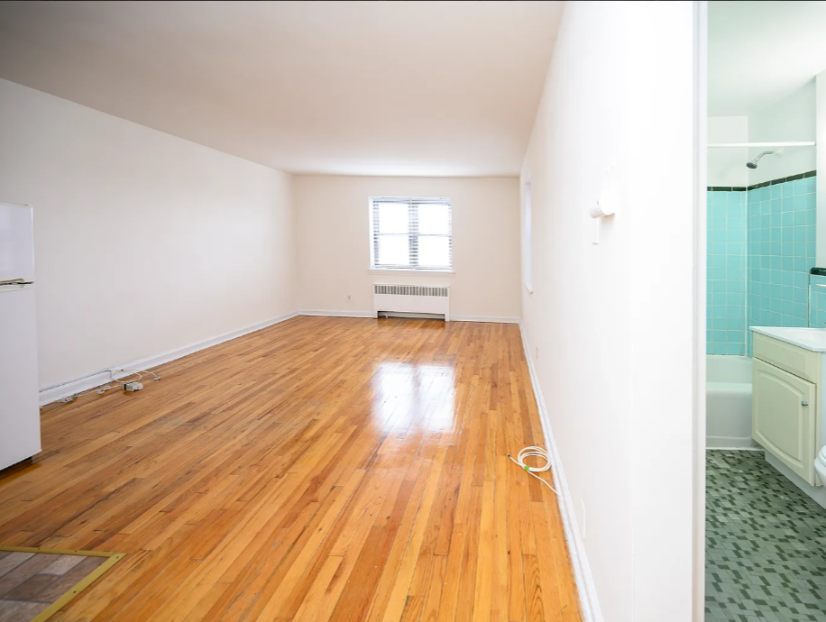 | King Alfred Apartments  862-227-1288  Office by appointment | Not stated - verify before applying | One-bedroom apartment option in a five-story Passaic building with elevator access, spacious hallways, card-operated shared laundry, indoor trash disposal, and convenient access to shopping, dining, daily services, and major highways. Confirm final rent, fees, utility charges, parking, and voucher policy before applying.
76-78 Market Street Unit 1  Paterson, NJ 07505 | $1,500/mo  1 bd, 1 ba | NOW | 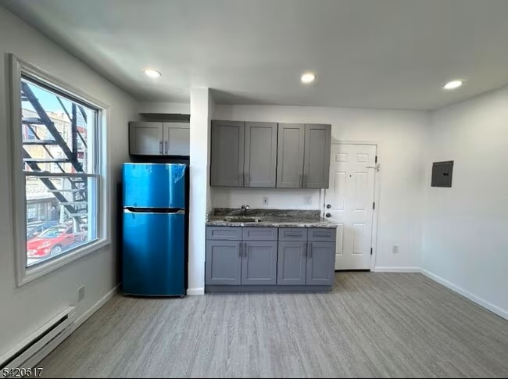 | David Vanegas  EXP Realty, LLC  862-407-6168 | Not stated - verify before applying | One-bedroom, one-bath Paterson apartment within the requested rent range. Listing details indicate building-photo access and a direct leasing contact. Confirm floor level, utilities, parking, required fees, security deposit, and voucher policy before applying.  Pet policy: No pets allowed.
46 E Main St  Paterson, NJ 07522 | $1,400/mo  1 bd, 1 ba | NOW | 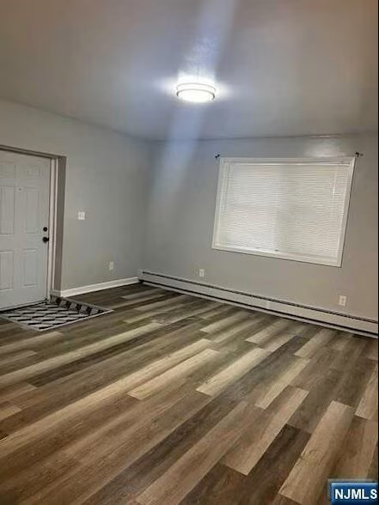 | 46 E Main St Leasing  862-453-8961 | Not stated - verify before applying | One-bedroom, one-bath Paterson apartment with total monthly price shown at $1,400. Public listing details describe a maintained apartment near shopping, parks, public transportation, hospitals, and local services. Confirm application requirements, lease term, included utilities, and Housing Choice Voucher policy.
324, 339 and 431 Broadway  324 Broadway, Paterson, NJ 07501 | $1,450+/mo  Studio, 1 ba  430 sq ft | NOW | 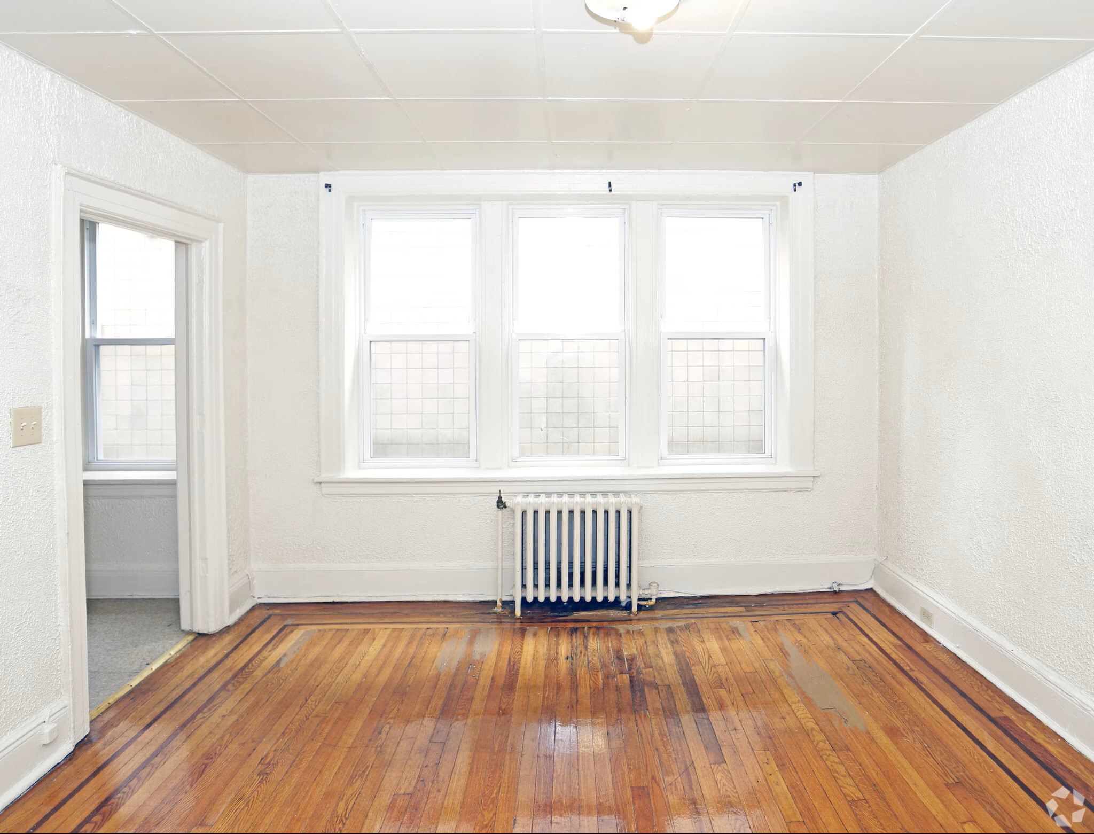 | Broadway Properties  973-604-8736  Office: Mon-Fri, 8:30 AM-5 PM | Not stated - verify before applying | Studio apartment option in a managed Paterson building near buses, trains, Passaic County Community College, shops, and downtown services. Public property details describe hardwood floors, high ceilings, kitchen appliances, elevator access, gated/key-fob entry, laundry facilities, water and heat included, and paid surface parking.  Pet policy: No pets allowed.
430 Lexington Ave APT 9  430 Lexington Ave APT 9, Clifton, NJ 07011 | $1,500/mo  1 bd, 1 ba | NOW | 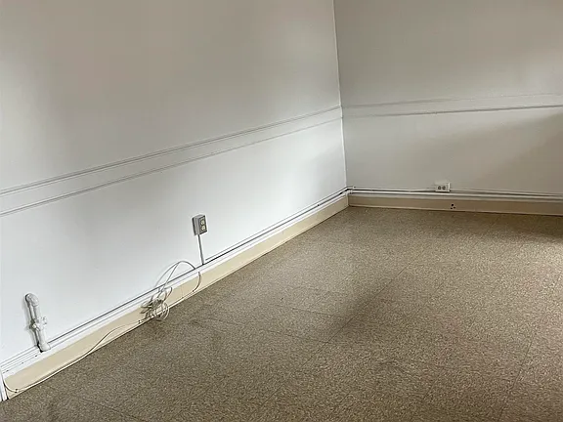 | Josephine LeBlang  Coldwell Banker Fort Lee  914-512-4011 | Not stated - verify before applying | Third-floor one-bedroom, one-bath Clifton apartment. Listing states tenant pays electricity and cooking gas, while landlord pays heat and hot water. Maximum occupancy is listed as two people, and tenant must bring their own refrigerator. Confirm application requirements and voucher policy before applying.  Pet policy: No pets allowed.
ESSEX COUNTY
Garden Spires Apartments  175-199 1st St, Newark, NJ 07107 | $1,050+/mo  1-3 bd options shown | NOW | 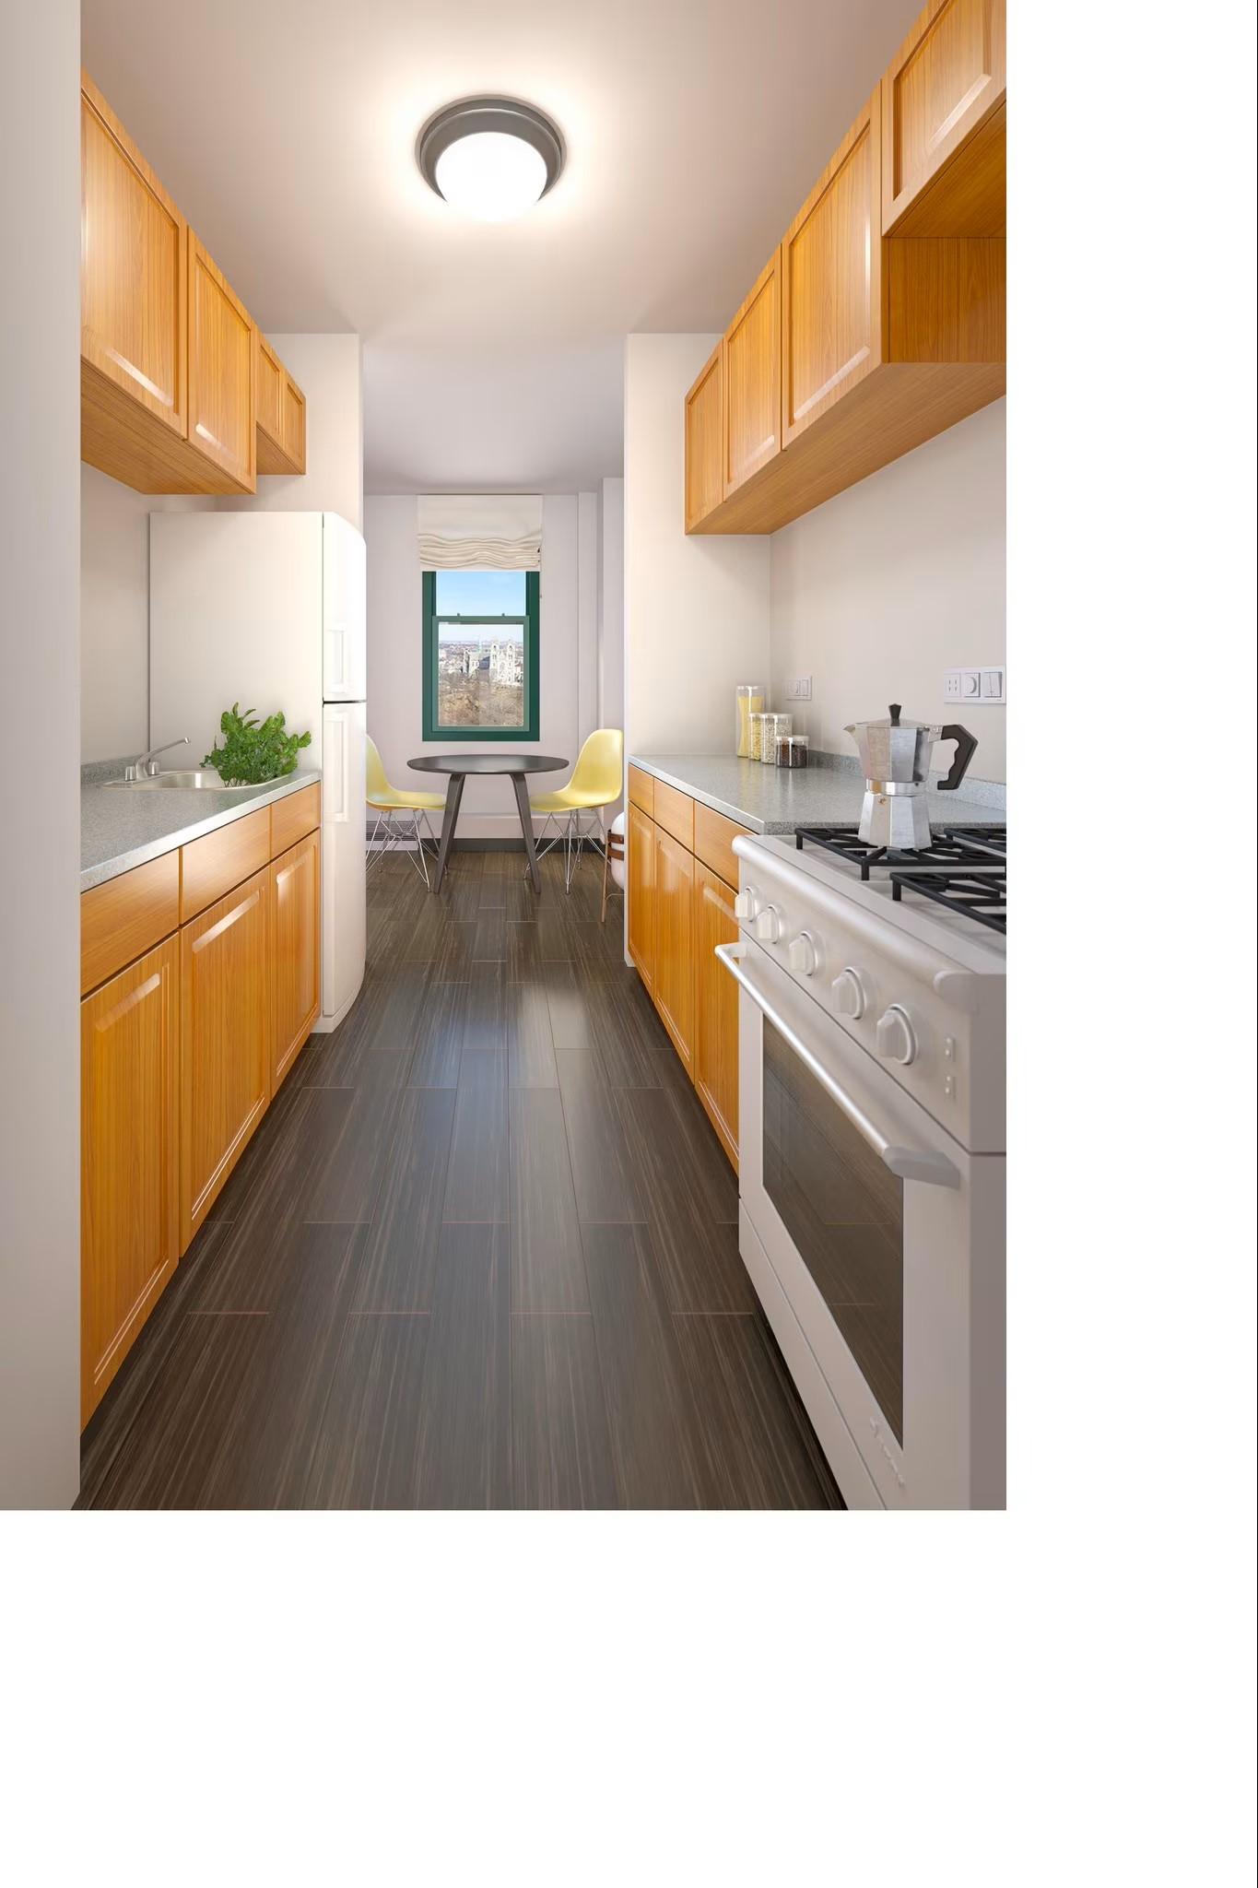 | Garden Spires Apartments  973-481-9200  Office: Mon-Fri, 9 AM-5 PM | Not stated - verify before applying | Newark apartment community with one-, two-, and three-bedroom options. Public property information describes renovated apartments, natural light, views, shared laundry, central air, and a location minutes from Newark Penn Station. Confirm exact available unit, price, fees, utilities, income limits, and voucher policy before applying.
311-312 Mount Prospect Ave #5J  Newark, NJ 07104 | $1,200/mo  Studio, 1 ba | NOW | 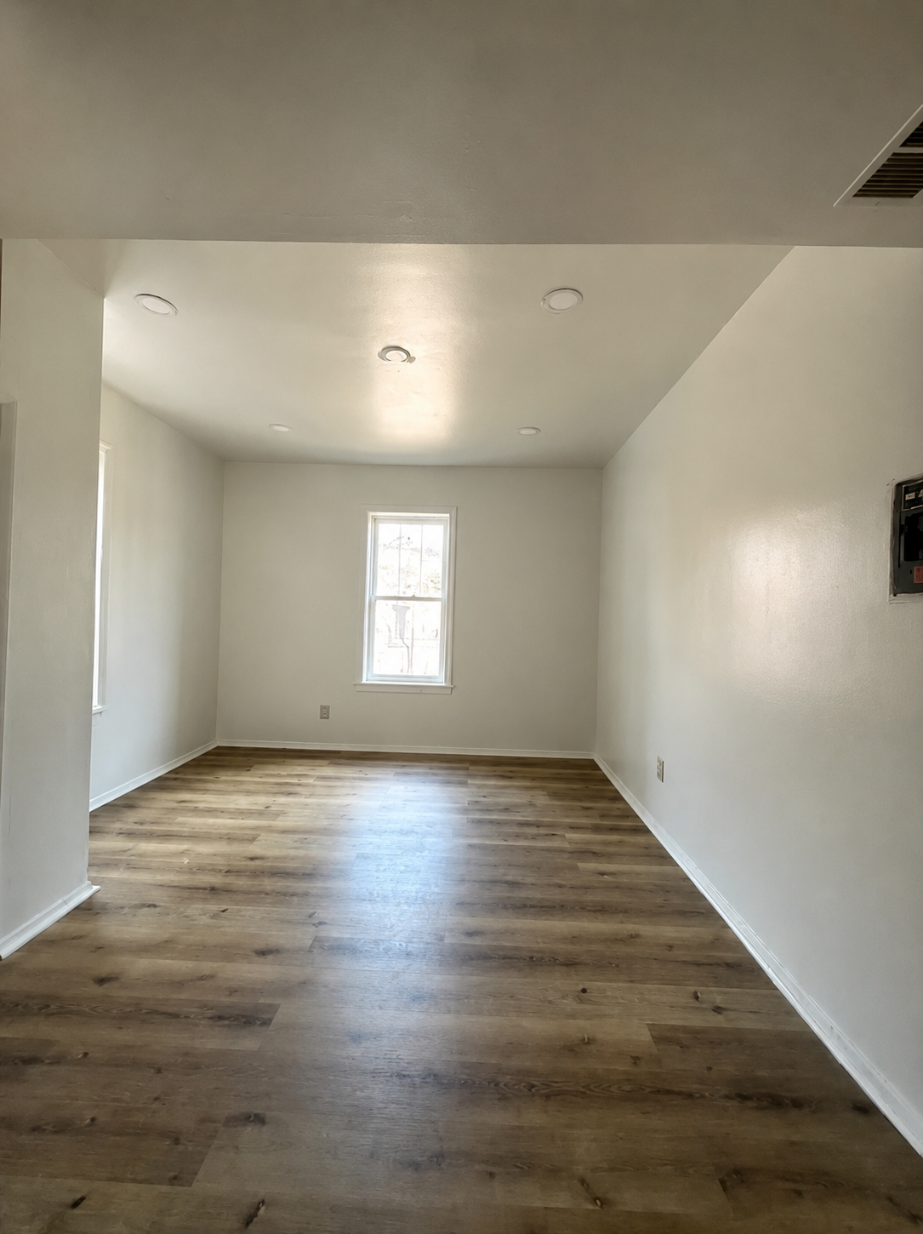 | 311-312 Mount Prospect Ave Leasing  201-581-9913 | Not stated - verify before applying | Studio, one-bath Newark apartment option in the Forest Hill area. Public listing details identify the unit as available for rent within the requested range. Confirm exact unit condition, lease term, deposits, utilities, application requirements, and voucher policy before applying.
High Park Terrace  36 Muhammad Ali Ave, Newark, NJ 07108 | $1,500/mo  1 bd | NOW | 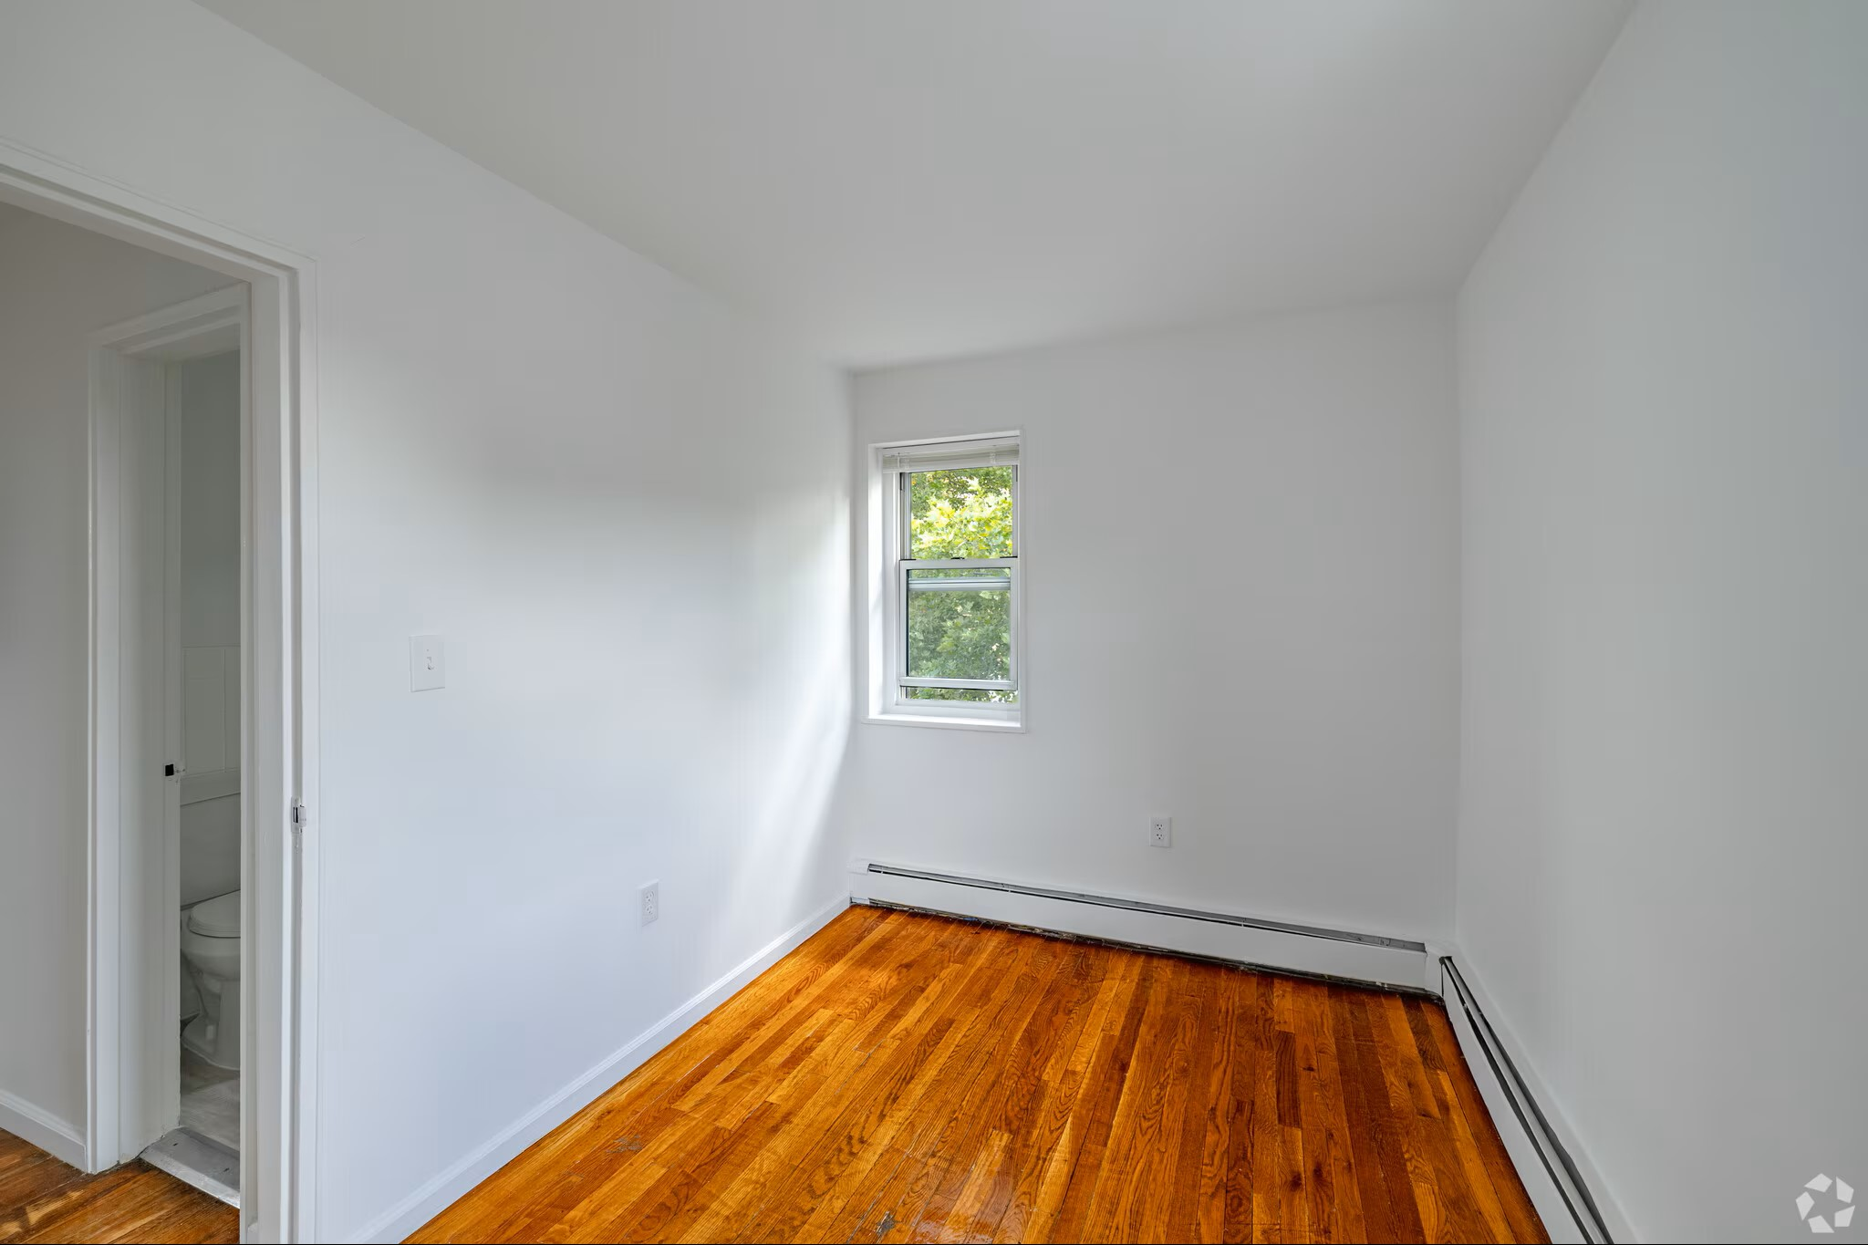 | High Park Terrace Leasing  908-460-8521 | Not stated - verify before applying | One-bedroom Newark apartment community option with building and garden photo access. Confirm available floor plan, total monthly charges, utilities, deposits, parking, lease term, and voucher policy directly with the leasing office before applying.
Forest Hill Terrace  325 Grafton Ave, Newark, NJ 07104 | $1,400+/mo  Studio | NOW | 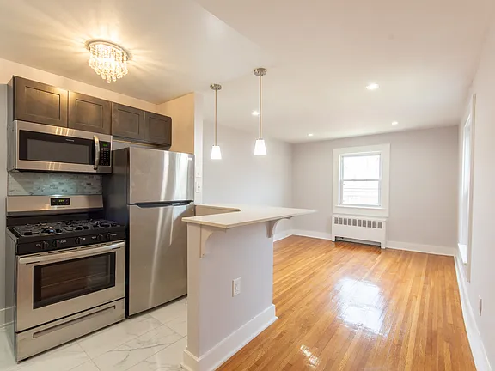 | Forest Hill Terrace Leasing  862-247-4188 | Not stated - verify before applying | Studio apartment option in Newark with interior photo access. Confirm exact unit, rent, square footage, utilities, laundry, parking, application fees, security deposit, and whether the property will work with voucher applicants before applying.
Glenwood Apartments  55 Glenwood Ave, East Orange, NJ 07017 | $1,428+/mo  Studio | NOW | 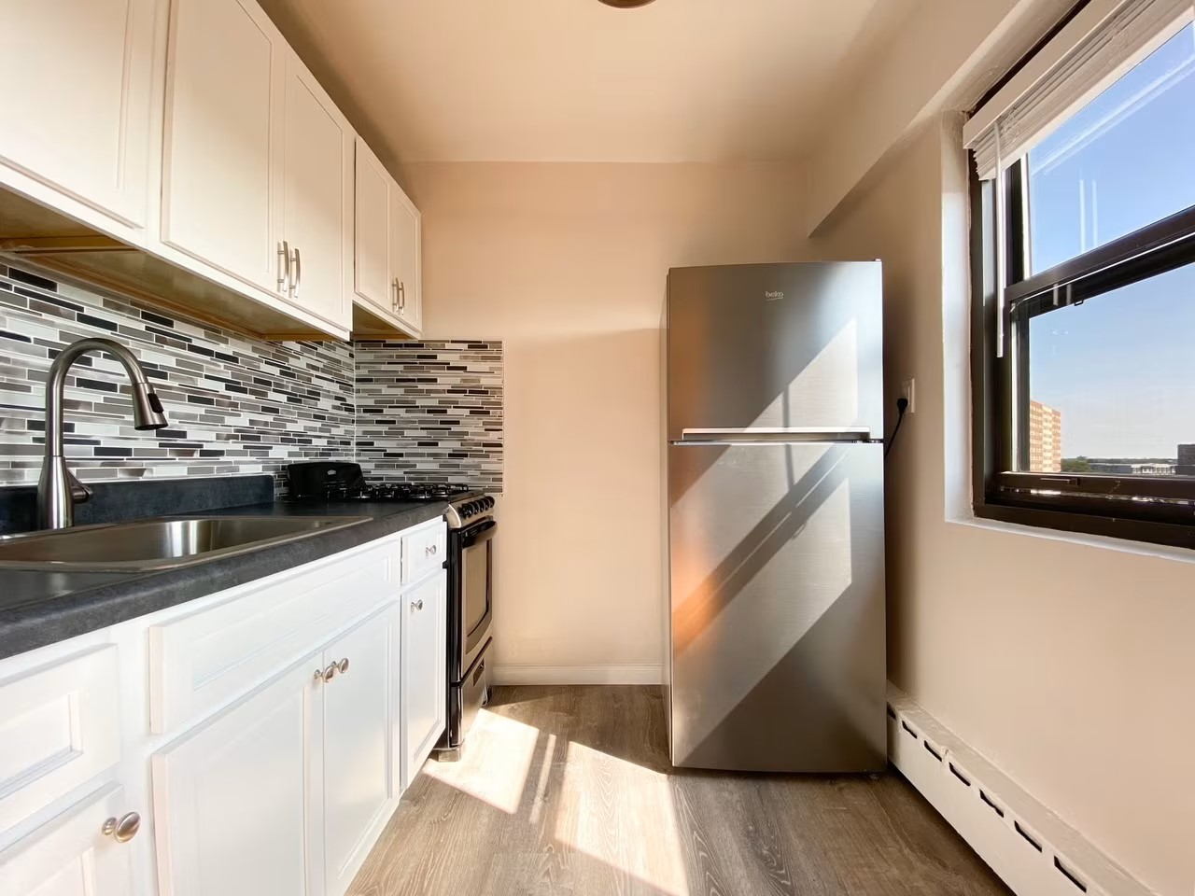 | Glenwood Apartments Leasing  973-542-9789 | Not stated - verify before applying | Studio apartment option in East Orange with exterior photo access. Confirm current floor plan, move-in date, lease terms, required fees, utilities, and whether the property will work with voucher applicants before applying.
101 Treacy Ave APT 33  101 Treacy Ave APT 33, Newark, NJ 07108 | $1,250/mo  1 bd, 1 ba  500 sq ft | NOW | 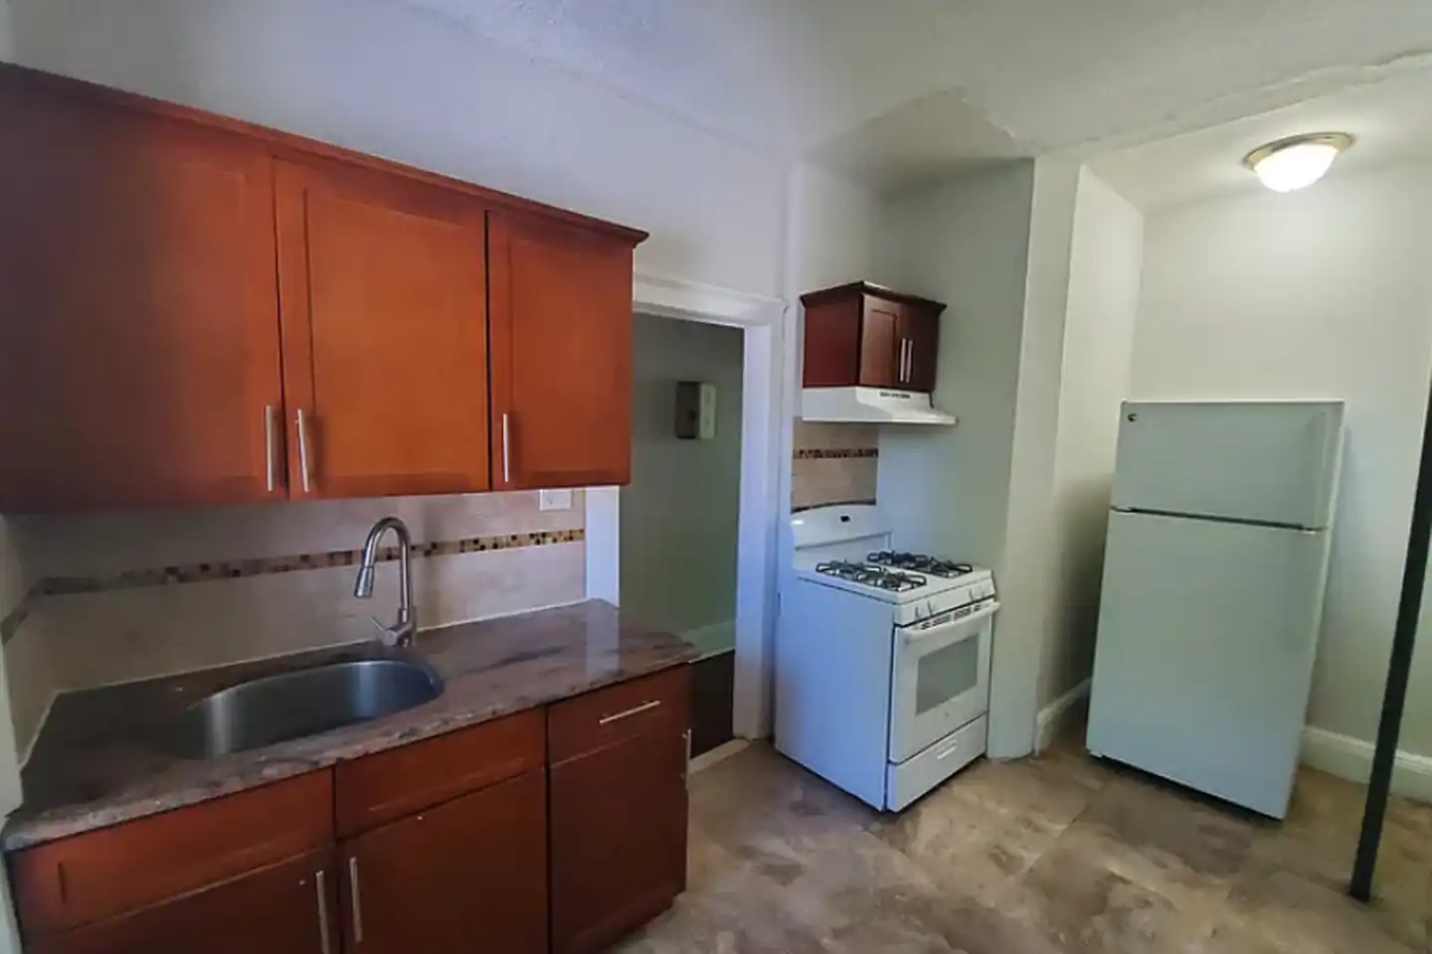 | 101 Treacy Ave Leasing  973-318-1847 | Not stated - verify before applying | Small one-bedroom, one-bath Newark apartment of approximately 500 square feet. Public listing describes it as a quiet apartment suitable for a single individual, close to major transportation, and listed within the requested rent range. Confirm deposit amount, fees, utilities, occupancy requirements, and voucher policy.  Pet policy: Pet friendly / cats and dogs allowed.
UNION COUNTY
Shami Apartments  400 Hamilton St, Rahway, NJ 07065 | $1,150+/mo  Studio, 1 ba | NOW | 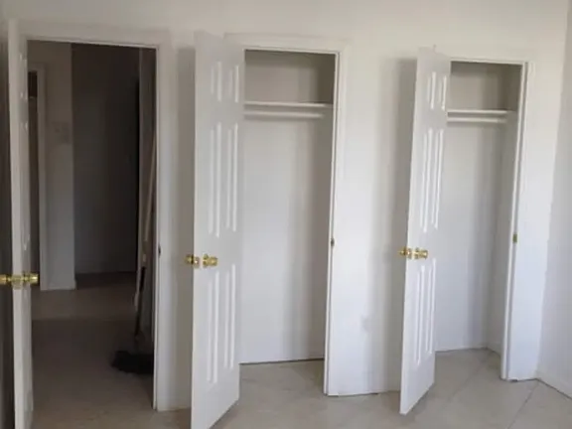 | Shami Apartments  848-668-8233 | Not stated - verify before applying | Studio, one-bath Rahway apartment option in a 48-unit apartment community. Public listing information instructs applicants to contact the property for details about floor plans, laundry, parking, and current availability. Confirm rent, deposits, fees, utilities, and voucher policy.  Pet policy: No pets allowed.
Linden Arms, LLC  811 Linden Ave, Elizabeth, NJ 07202 | $1,480+/mo  Studio | NOW | 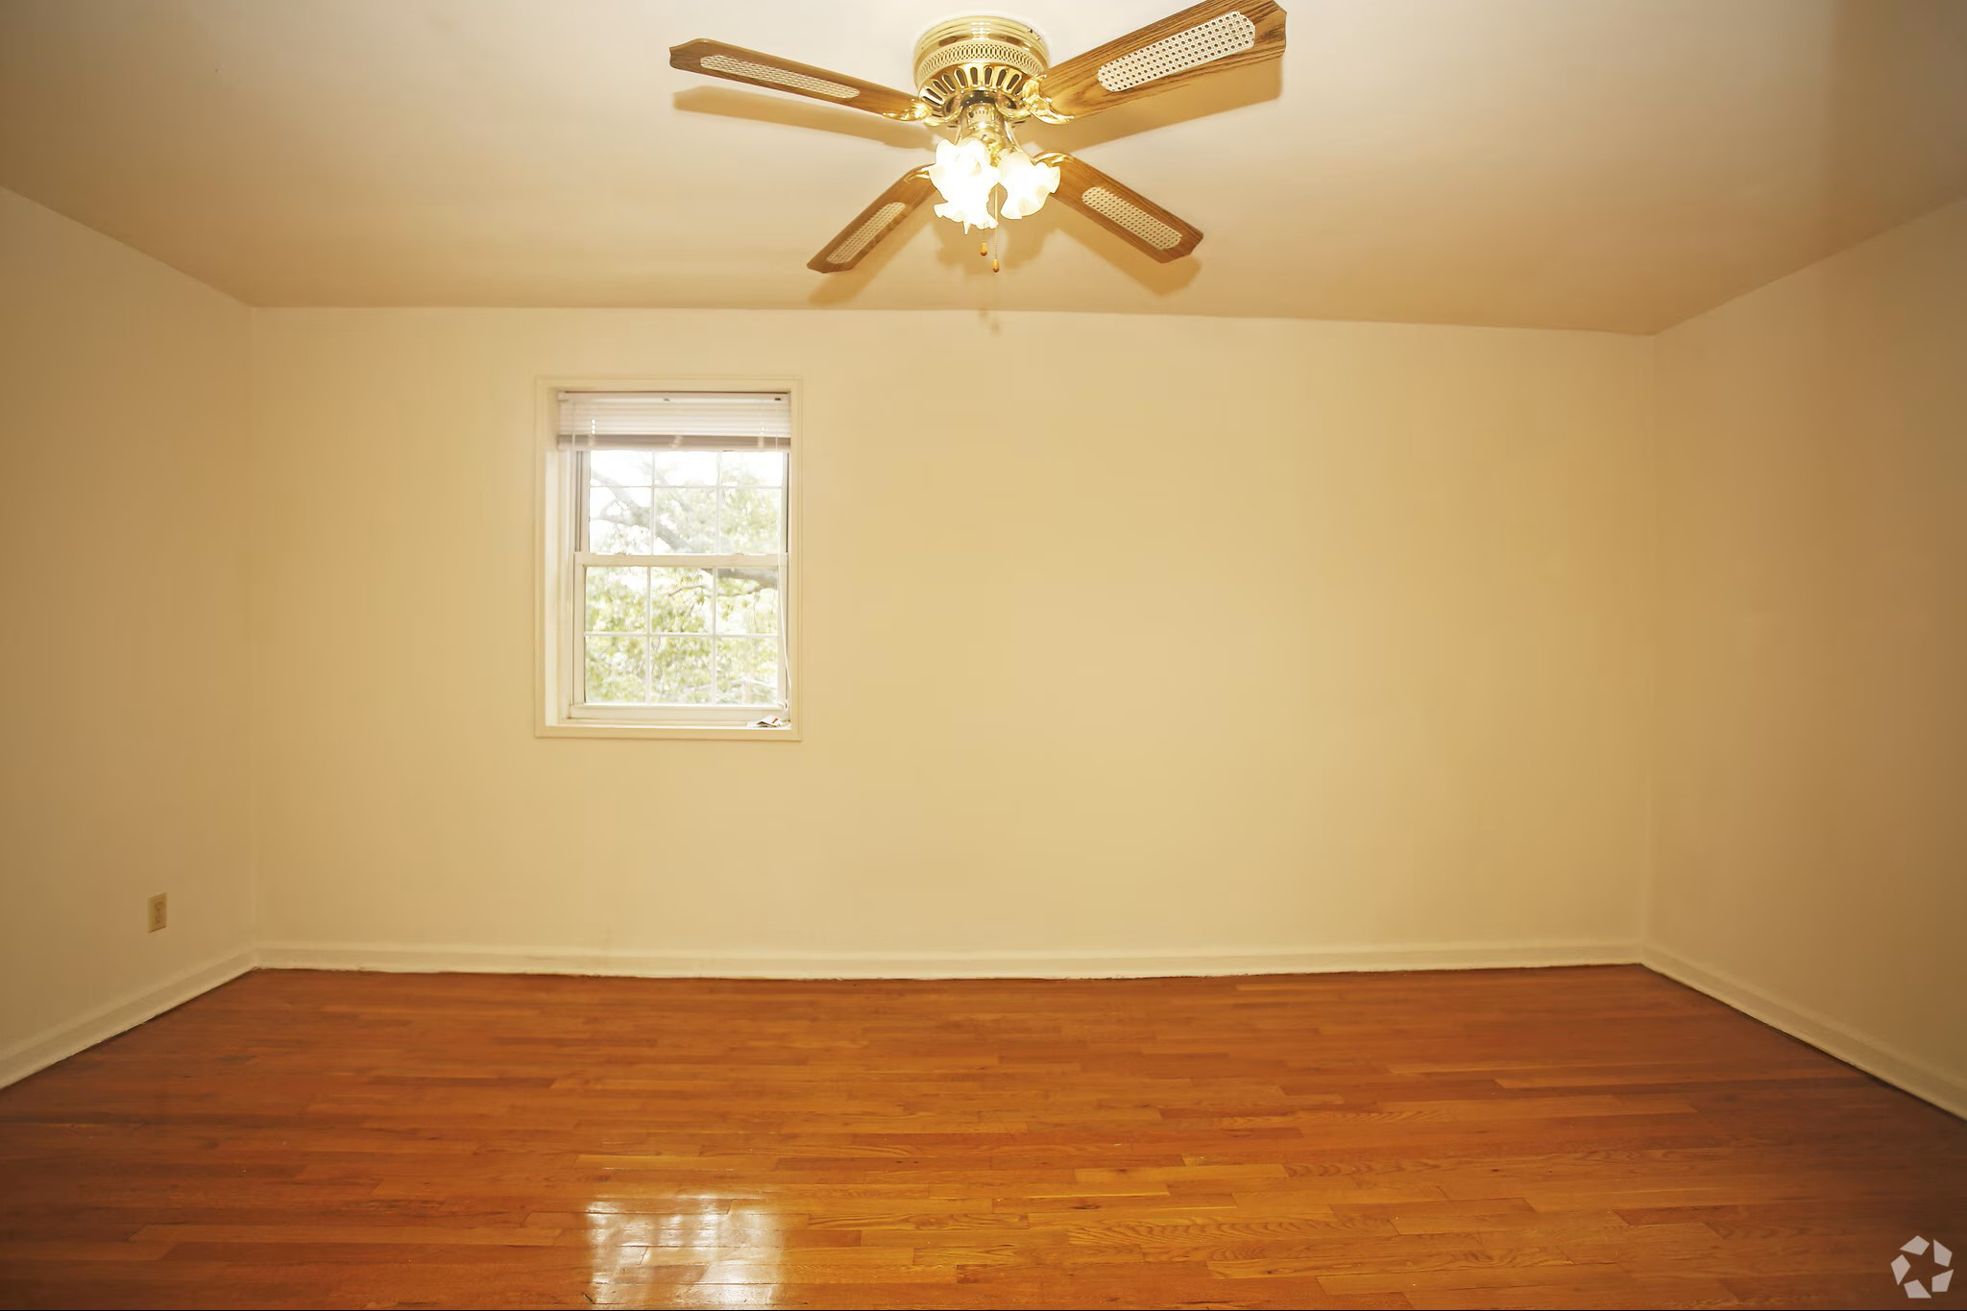 | Linden Arms Leasing  908-540-7630 | Not stated - verify before applying | Studio apartment option in Elizabeth with direct leasing phone contact. Confirm the exact unit, current rent, deposits, application fees, parking, utility responsibility, and voucher policy before applying.
Westminster Towers Apartments  801 N Broad St, Elizabeth, NJ 07208 | $1,400/mo  Studio | NOW | 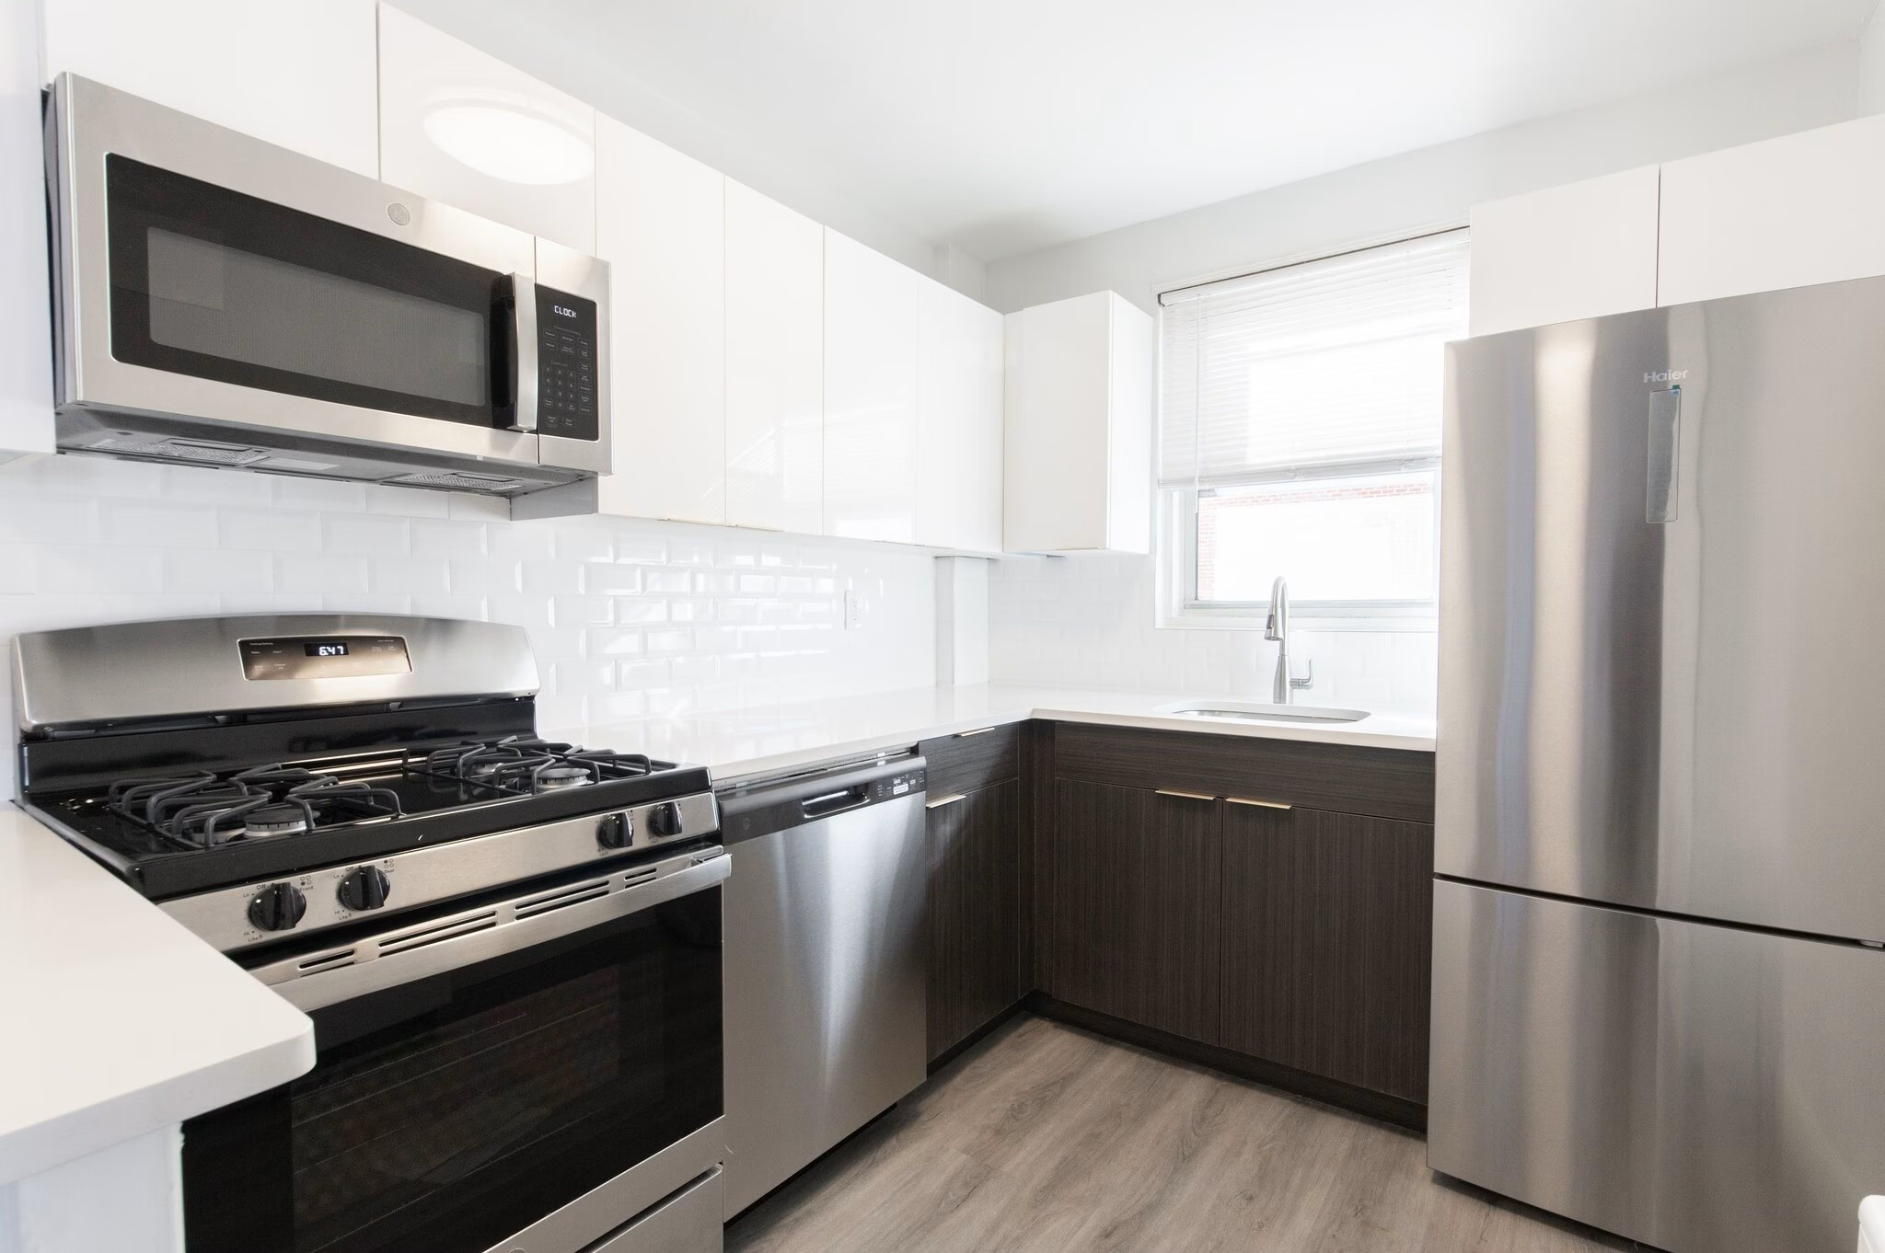 | Westminster Towers Leasing  908-987-2385 | Not stated - verify before applying | Studio apartment option in Elizabeth with a direct leasing contact. Confirm availability, rent, deposits, income/credit requirements, utilities, parking, and whether Housing Choice Vouchers are accepted before applying.
Wood Arms Apartments  30 E Elm St, Linden, NJ 07036 | $1,450+/mo  Studio | NOW | 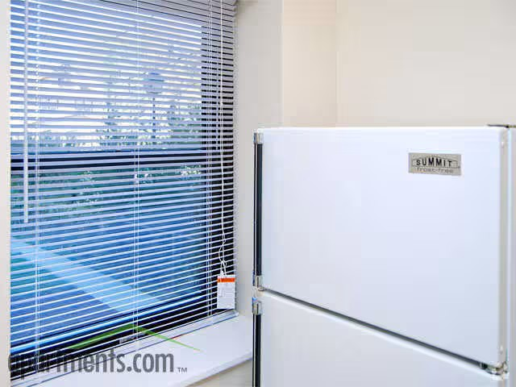 | Wood Arms Leasing  908-738-9854 | Not stated - verify before applying | Studio apartment option in Linden with a direct leasing phone number. Confirm exact available unit, move-in date, total monthly charges, utilities, laundry, parking, application requirements, and voucher policy before applying.
Heritage Village at Elizabeth, 62+ Community  225 2nd St, Elizabeth, NJ 07206 | $1,229/mo 1 bd  $1,480/mo 2 bd | NOW | 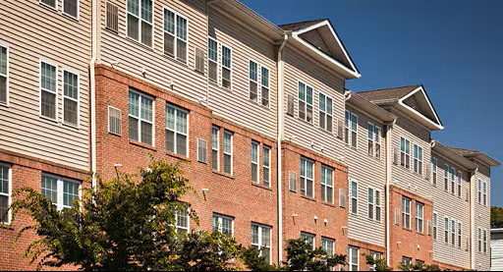 | Heritage Village Leasing  908-460-1958 | Senior community - verify voucher eligibility and rent limits | Age-restricted 62+ Elizabeth community with one- and two-bedroom options listed within the requested range. Confirm age eligibility, income qualifications, application process, waitlist status, utilities, fees, and Housing Choice Voucher compatibility before applying.
Portside II  136 Pine St, Elizabeth, NJ 07206 | $1,017/mo 1 bd  $1,209+/mo 2 bd  $1,397+/mo 3 bd | NOW | 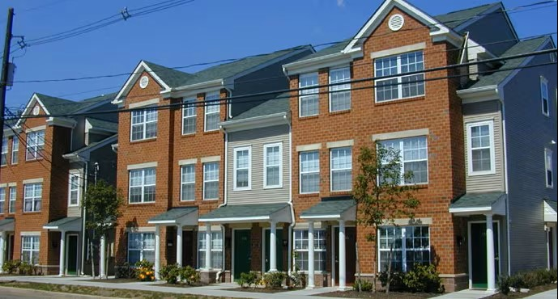 | Portside II Leasing  201-380-8964 | Verify income restrictions and voucher acceptance | Elizabeth apartment community with one-, two-, and three-bedroom prices shown within the requested range. Confirm unit availability, household-size rules, income qualifications, utility allowances, deposits, and voucher acceptance before applying.

SOURCE AND VERIFICATION NOTES
• This listing is a community resource document, not a guarantee that a unit is still available.
• Prices, fees, availability, deposits, utilities, pet policies, income requirements, and Housing Choice Voucher acceptance can change without notice.
• Housing voucher status is marked YES only where a public listing or voucher-specific rental source explicitly indicated Section 8 / voucher-related availability; otherwise, verify before applying.

